ARCHIVE AND COMPRESSION FILES

**Received** OCT 12, 2022, **accepted** OCT 20, 2022 **final submission** NOV 22, 2022 **extend date** NOV 28, 2022

**ARCHIVE AND COMPRESSION FILES**

Submitted by: -

SONPAL (12217639)

Submitted to: -

MISS. PALLVI (28462)

1. **Introduction:**
2. ARCHIVING FILES

* Archiving is to combine a group of files organized in a tree structure into one file
* This enables easier handling, such as for backup or transfer purposes
* This is a separate procedure from compression
* The tool used for archiving files is “tar”

1. COMPRESSING FILES

* Compressing files is the procedure of reducing the size of the file by a tool that removes any redundant data in the file
* File compression is a data compression method
* In which the logical size of a file is reduced to save disk space
* File compression is known as file zipping

1. **Objective:**

* Archiving is the process by which inactive information, in any format, is securely stored for long periods of time
* Archiving is important for legal reasons too
* Compression of files is the main process of compressing into smaller sizes to save storage space in hard drives
* Compression of file, In which the logical size of a file is reduced to save disk space for easier and faster transmission over a network or the internet

1. **Conclusion:**

An archive multiple files into a single archive and then compress it, or compress an individual file. The former is still referred to as archiving, while the latter id just called compression. When you take an archive, decompress it and extract one or more files, you are un-archiving. It can often be faster to compress a file before you send it to a tape drive or over a slower network and decompress it on the other end than it would be to send it uncompressed. Archiving and compressing files are common operations in the UNIX world, done by system administrators on a very regular basis.



Archiving and compressing files are common operations in the UNIX world, done by system administrators on a very regular basis.

Luckily for you, Linux exposes a set of different commands in order to archive, compress, uncompressed and extract files from an archive.

**Archive files on Linux using tar**

Tar is a very popular command among system administrators.

Nowadays, the tar command is widely used in order to archive files (meaning putting files together in a single archive).

To archive files on Linux using tar, run “tar” with the “cvf” options.

In this case, we used three different options:

-c: for create archive, a pretty self-explanatory option if you want to create a new archive made from the files selected;

-v: for verbose, this is the reason why the command displays the files added to the archive when executing it;

-f: for file, this option is used in order to specify the filename of the archive we want to create (in this case archive.tar).

Those options are probably the most important options for archiving files on Linux.

When running the tar command with the “-f” flag, a new archive was created in your current working directory. Create a directory archive.tar and create some other directory inside the archive.tar and create some text file.

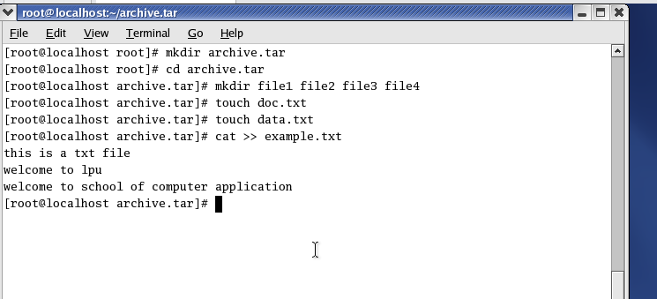

Check the directory archive.tar

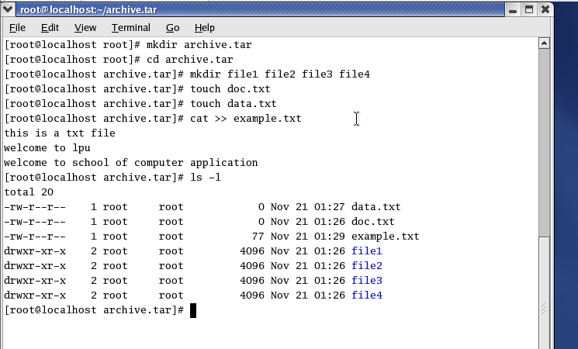

Convert the archive.tar into tar file name is TAR.

**#tar –cvf TAR archive.tar**

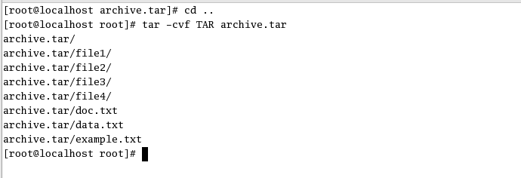

This is a very important fact because we are able to understand that archiving files does not mean that your files are compressed in it.

**Extract files using tar on Linux**

Now that you have created an archive file, you may want to extract the files located in your archive.

To extract files using the tar command, append the (-x option instead of the initial “-c” option)**.**

**#tar –xvf TAR**

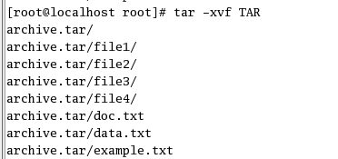

**Compressing Files at the Shell Prompt**

Red Hat Enterprise Linux provides the **bzip2**, **gzip**, and zip tools for compression from a shell prompt. The **bzip2** compression tool is recommended because it provides the most compression and is found on most UNIX-like operating systems. The **gzip** compression tool can also be found on most UNIX-like operating systems. To transfer files between Linux and other operating system such as MS Windows, use zip because it is more compatible with the compression utilities available for Windows.

**Compression Tools**

By convention, files compressed with **bzip2** are given the extension .**bz2**, files compressed with **gzip** are given the extension .**gz**, and files compressed with zip are given the extension **.zip**.

Files compressed with **bzip2** are uncompressed with **bunzip2**, files compressed with **gzip** are uncompressed with **gunzip**, and files compressed with zip are uncompressed with unzip.

**Bzip2 and Bunzip2: -**

To use bzip2 to compress a file, enter the following command at a shell prompt:

**#** **bzip2 filename**

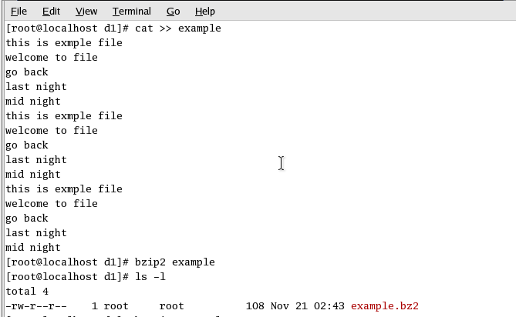

To use bunzip2 to uncompress a file, enter the following command at a shell prompt:

# **bunzip2 filename.bz2**

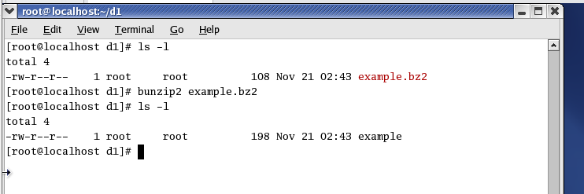

**Gzip and Gunzip: -**

To use **gzip** to compress a file, enter the following command at a shell prompt**:**

**#** **gzip filename**

To expand the compressed file, enter the following command:

**#gunzip example.gz**

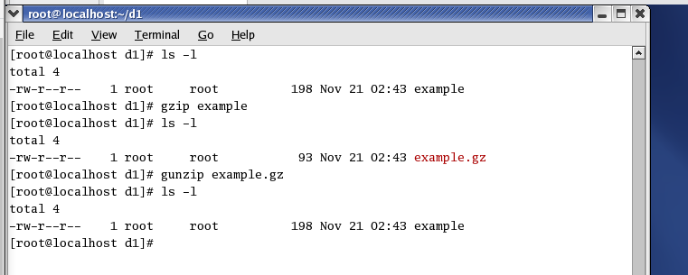

You can use **gzip** to compress multiple files and directories at the same time by listing them with a space between each one:

**#gzip - r file1 file2 file3**